# **Weekly Report – W17 Fall 2022**

## **Problem & Task**

1. Since it is not so meaningful to repeat the simulation for the equipment STIFF-FLOP module which has a totally different geometry parameters as our project, and last week I have tested the performance for 200 mm long SRA (with other parameters as close to our project’s as possible), the results were acceptable, but for longer ones, the simulation failed. Thus this week, we can try to enlarge the density of the material to see if 300 mm SRA would lead to a better simulation result;
2. The problem of using others’ package is that if there emerged a bug or error, it would be hard for us outsiders to figure it out even though for a mature package; therefore, on the other hand, we also need to develop our own simulation environment which is under well controlled, just in case. The simulation will still be a free falling ball tied by two equal-length SRAs, the only difference is that the compliance of the SRA will be represented by a damper and spring between the COMs of each adjacent links/segments, more details can be seen in the section below.

## **Solution**

1. *SRA simulation with higher density*

Firstly, for the convenience of future simulation of our project, it’s better to make a record of the exact dimensions of the SRA instead of measuring them or changing the units again and again. For the dimension of the inner radius, temporarily I haven’t found any tapes, so I used the belt to wrap around the SRA to roughly calculate it. The units in the following two figures are all inches, we have to change them into metric units to uniform with those in the package.

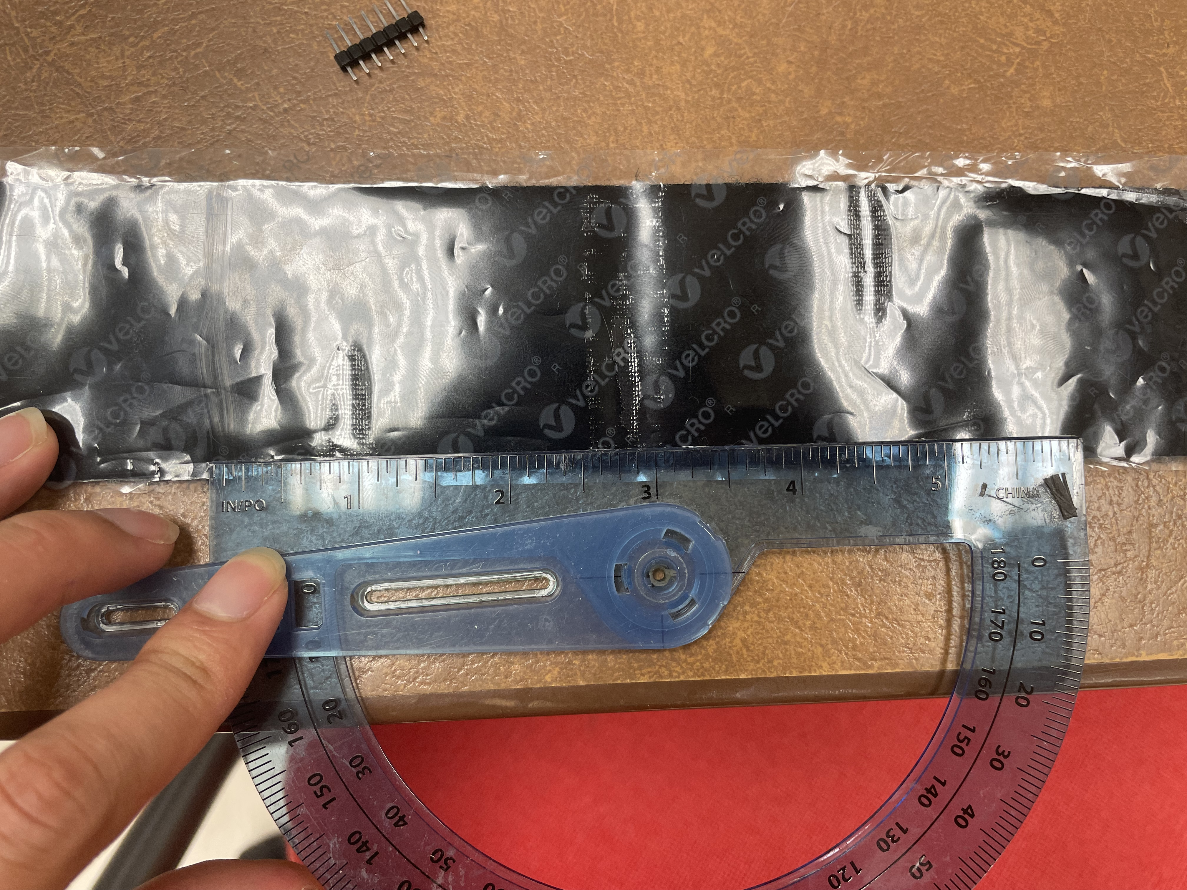 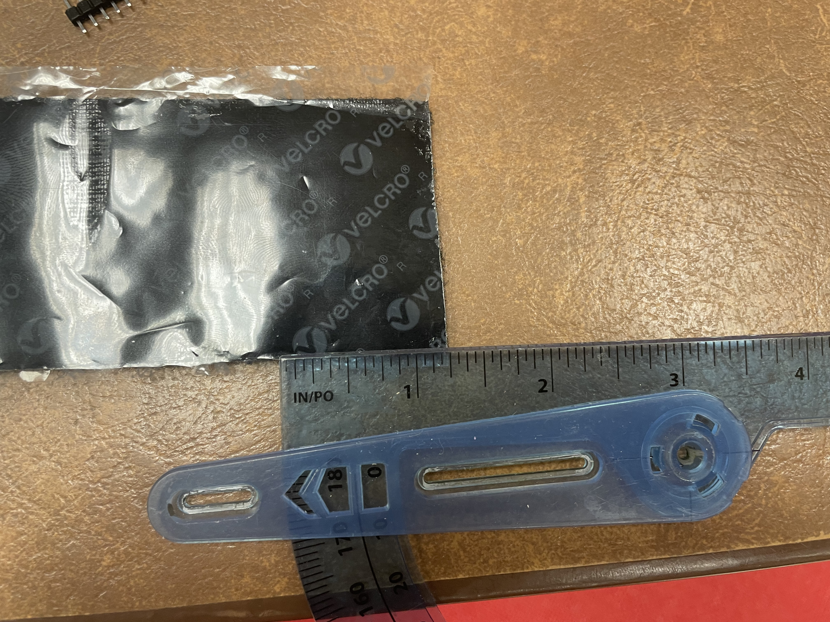

**Fig. W17-1** The total length of the cross section area of SRA by using belt wrapping around SRA

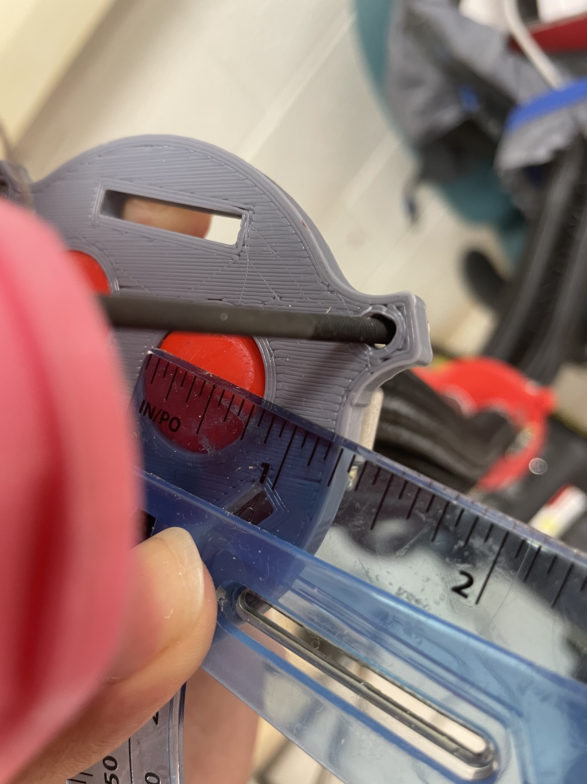

**Fig. W17-2** The inner radius of each chamber

And what’s more, the geometry factor inputs in the package were designed to be more explicit that we also need to confirm the outer radius of the chamber and the whole SRA; to make them look reasonable, we need to take a reference about the thickness of each wall. In the paper, the thickness was set to be 8 mm for the SRA, and 0.5 mm for each chamber, I decided to make them 8 mm and 1 mm respectively so that the dimension can be summarized as follows,

**Table W17-1.** The dimension set for simulation

|  |  |
| --- | --- |
| **Name** | **Dimension** |
| Length of each segment of SRA $L$ | 300 mm |
| Manipulator inner radius $r_{s1}$ | 30 mm |
| Manipulator outer radius $r_{s2}$ | 38 mm |
| Pressure chamber inner radius $r_{p1}$ | 9.5 mm |
| Pressure chamber outer radius $r_{p2}$ | 10.5 mm |
| Density of SRA $ρ$ | $5460 g/{{cm}^{3}}$ (about 3 times of the default setting) |

To test the performance of the package with our SRA geometry settings, the first simulation done was no load on the SRA tip, and the result is shown as follows,

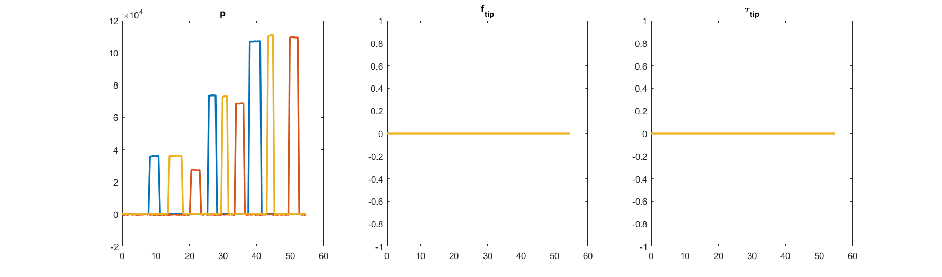

**Fig. W17-3** The default input for simulation 1 (no external load on the tip)

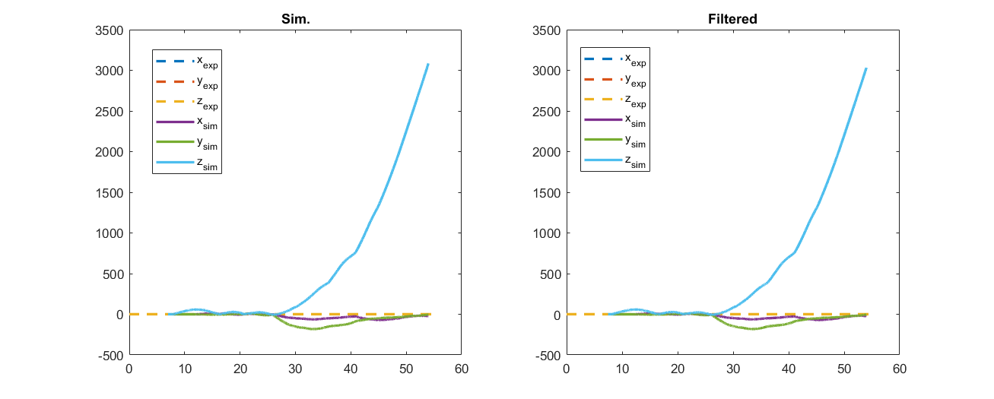

**Fig. W17-4** The position of the tip for simulation 1

We can see that even with the original default input, the position simulated seemed to be an irrational magnitude, but much better compared to the simulations done for the previous several weeks. However, we cannot make a conclusion that the package is not suitable for our project. So I did more simulation for force input only (0.8 N in x direction), and I set the pressure in all the chamber equally, and 0.5 bar, 1 bar and 2 bar respectively, the results are shown below.

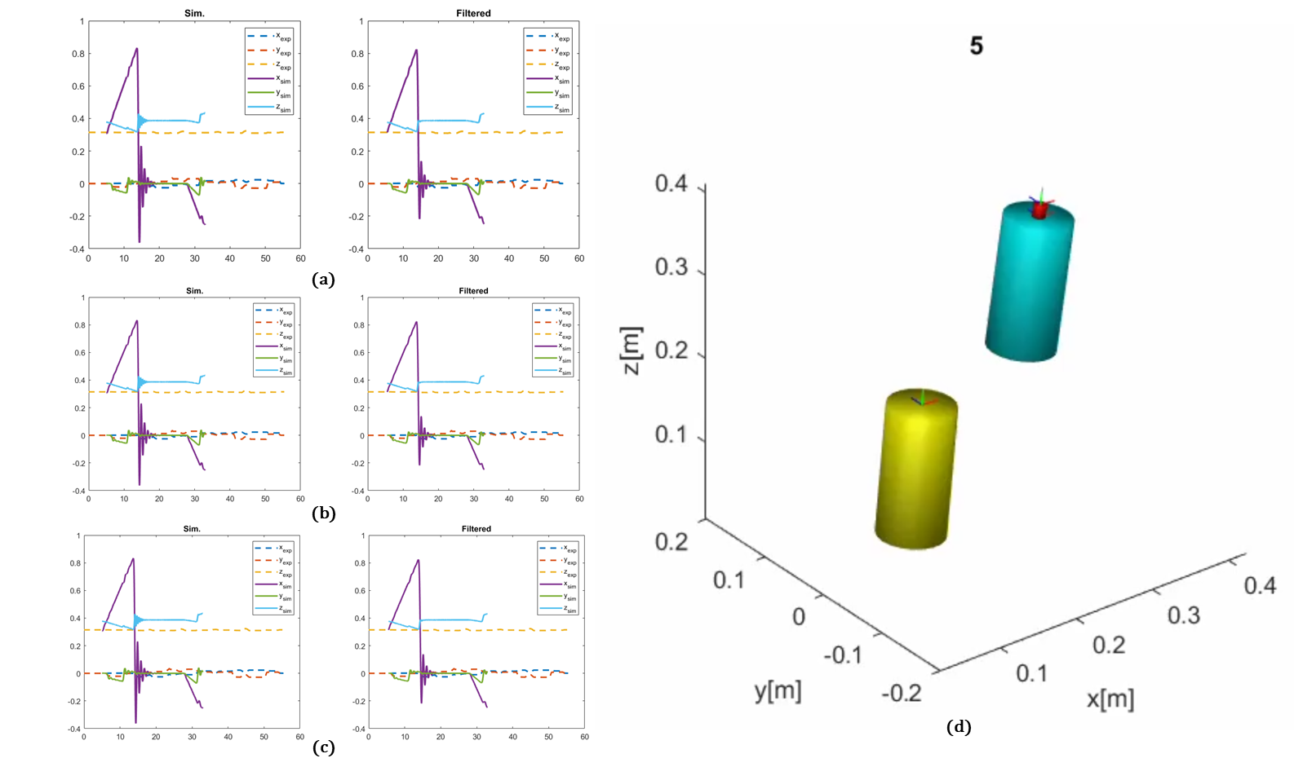

**Fig. W17-5** The simulation results for 0.8 N force exerted on SRA tip in x direction with different pressure input. (a) $P_{1}=0.5 bar$, (b) $P_{2}=1 bar$, (c) $P_{3}=2 bar$ and (d) the animation for $P_{2}=1 bar$.

From the results we can found that the pressure didn’t affect so much about the simulation results, and they were basically in the same trend of the force change, which is a good sign. All the position variations looked reasonable, and in the controllable range, so it can be proved that the simulation package is of no problem, it is suitable for our SRA and we still can trust it. The only thing worth note that is the animation behaved a little abnormal this time, the two segments went apart even at the beginning of the simulation. **My thought** was that it could be due to the high density we set or the high pressure. So I did another two set of groups of tests, the position plots look good, but the animation still had the same problems, so I turned to change the dimensions, for the manipulator inner radius, from 30 mm to 32 mm and accordingly the outer radius will be 40 mm. And the results are shown as follows,

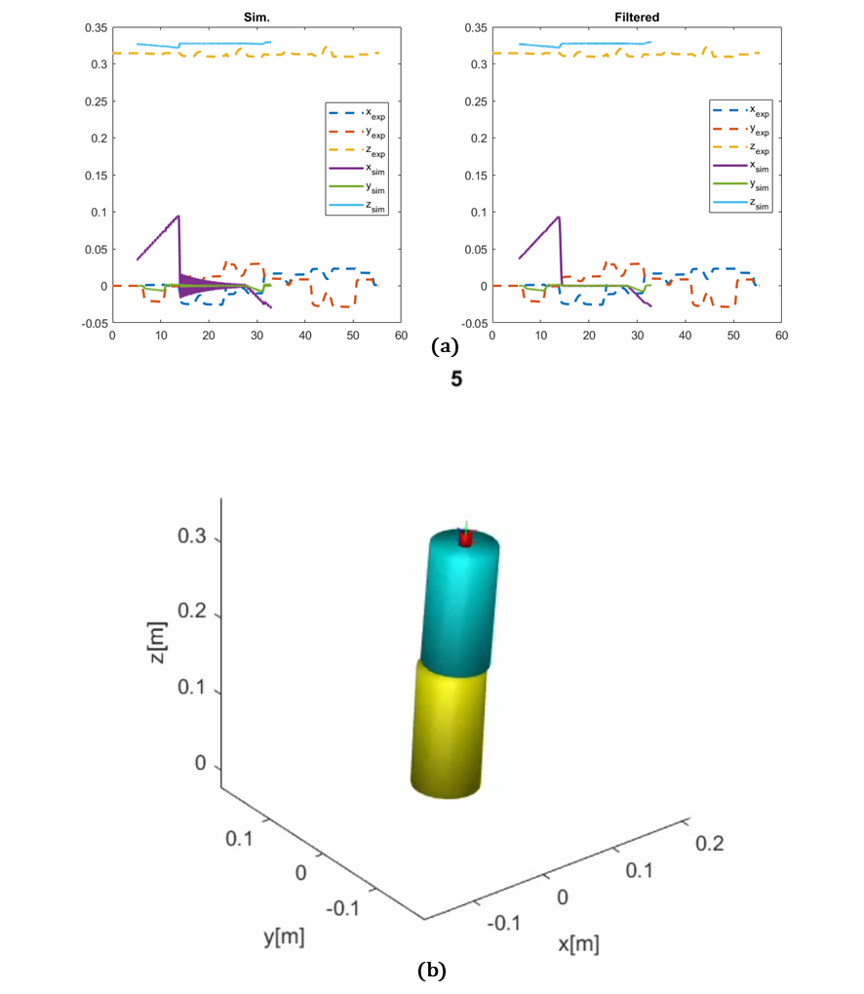

**Fig. W17-6** The simulation results for 0.8 N force input exerted on the SRA tip in the x direction with no pressure pumped and with SRA outer and inner radius changed. (a) position of the tip, (b) animation for this simulation.

This time the animation was better even though the two segments were a little bit mismatched at the start, but I think it is still a serious issue, because for larger pressure pumped, the two cylinders looked almost straight without any bending or rotations, I’ll try to find the reason behind, one conclusion can be drawn based on the simulation this week, the geometry factors indeed domain the success of the simulation, the reason why the simulation got failure in the last few weeks could be that we were not so rigorous about the dimensions, so I updated with the calibrated ones as follows.

**Table W17-2.** Calibrated dimension settings for simulation

|  |  |
| --- | --- |
| **Name** | **Dimension** |
| Length of each segment of SRA $L$ | 300 mm |
| Manipulator inner radius $r_{s1}$ | 32 mm |
| Manipulator outer radius $r_{s2}$ | 40 mm |
| Pressure chamber inner radius $r_{p1}$ | 9.5 mm |
| Pressure chamber outer radius $r_{p2}$ | 10.5 mm |
| Density of SRA $ρ$ | $1820 g/{{cm}^{3}}$ (about 3 times of the default setting) |

1. *Free ball falling simulation with two SRAs*

Since the coding work is still in process, here I will introduce the detailed information about the modelling, which is slightly different from our initial version based on constant curvature theory, and its compliance is represented by bending stiffness and damping.

To be brief, the assumptions of the simulation V2 are as follows:

* A ball is tied with two soft robot arms, each of them has two segments, which can be deemed to be rigid bodies, and the other side of each SRA was fixed on two walls on the same altitude throughout the simulation time;
* The ball will be released from a reasonable position rightly in the middle of the two walls, which needs to be evaluated before the simulation, because the two arms cannot be extended;
* To represent its compliance (the properties of soft robots), the damping and stiffness coefficients are added through adding a spring and damper, which are parallel with each other, between the COM of each two adjacent segment (for a single arm), the conceptual modelling is shown as follows;

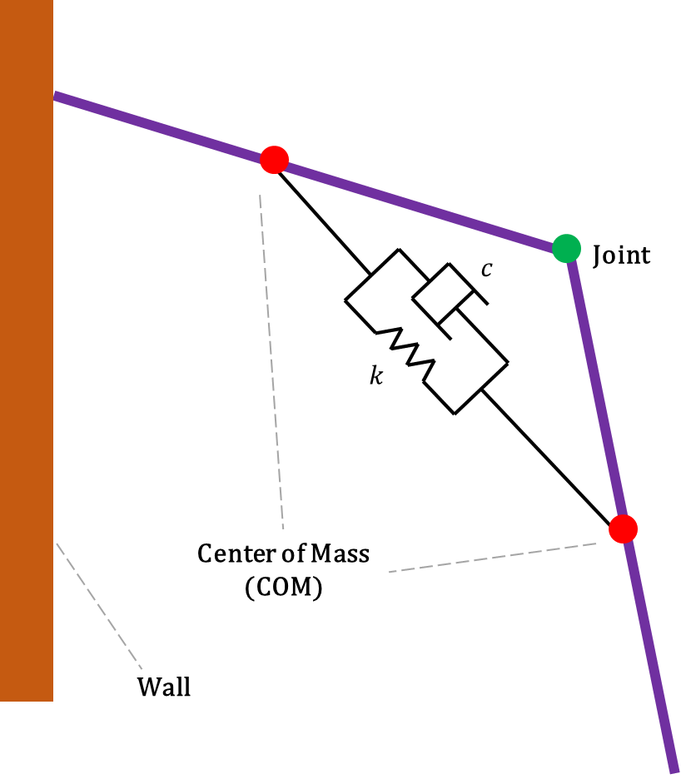

**Fig. W17-7** The schematic of the modelling for V2

* The definition of the degree of freedom will be totally different as this model is not based on PCC, the angle change should be measured referenced by the wall, which also means that the governing equations will be different as well.

1. *Additional Test*

(1). Erase the physical experimental data

The final simulation result recording the position change of the SRA tip with respect to the simulation time step was not plotted in the main function (which was original system.m), so there must be somewhere else the plot function has been used. My solution is to search “plot” in each sub-function to find if we can lock up its location.

**Table W17-3.** The check list of the functions in the TMTDyn package

|  |  |  |  |  |  |
| --- | --- | --- | --- | --- | --- |
| File Name | File or Function Name | | | Description | |
| TMTDyn_Falling_SRA | eom | **×** | | The EOM has to be derived for each simulation each time, no need to check. | |
| exp | Load1 | ✔ | All of them are just data file, | |
| Load2 | ✔ |
| Noload | ✔ |
| hll | analysis_builder | ✔ | No plot. | |
| body_builder | ✔ | No plot. | |
| damper_builder | ✔ | No plot. | |
| dof_builder | ✔ | No plot. | |
| eom_derive_builder | ✔ | plotIC  4 key words "plot" were found, but not plot function. | |
| exload_builder | ✔ | No plot. | |
| joint_builder | ✔ | No plot. | |
| mesh_builder | ✔ | No plot. | |
| pipeline | ✔ | Key word “plot” is in comment. | |
| post_process_builder | ✔ | plot_points_val  3 key words “plot” were found, self-edited function. | |
| reference | ✔ | Just an example of the start-up file. | |
| reference_new | ✔ | Just an example of the start-up file with new version. | |
| robot_builder | ✔ | No plot. | |
| rom_builder | ✔ | No plot. | |
| simulation_builder | ✔ | No plot. | |
| spring_builder | ✔ | No plot. | |
| template_builder | ✔ | 3 key words “plot” were found.  Tubeplot func was added in the path;  One of them is in the comment;  The left one is plotIC func. | |
| tmtdyn | ✔ | No plot. | |
| transformation_builder | ✔ | No plot. | |
| world_builder | ✔ | No plot. | |
| results | results_post_proc | ✔ | These are mat file, just store data in the format of matrix, no plot func. | |
| results_sys | ✔ |
| tmtdyn | funcs | myJacobian.m |  |  |
| piecewise2logistic.m |  |  |
| Q_conj.m |  |  |
| Q_mult.m |  |  |
| Q_omega.m |  |  |
| Q_rot.m |  |  |
| R2Q.m |  |  |
| smoothV.m |  |  |
| smplfy.m |  |  |
| sprse.m |  |  |
| TQ_mult.m |  |  |
| igesToolBox_edited | **×** |  | |
| radau | **×** | External ODE solver, no plot. | |
| sundials_external_c | **×** | External ODE solver, no plot. | |
| sundials_matlab | **×** | External ODE solver, no plot. | |
| tubeplot | tubeplot.m | **×** | This function is all about animation. |
| anim | ✔ | 26 key words “plot” were found. Most of them are coming from the comments, plot3 and subplots, just few from tubeplot, all the plot functions used are basically about 3D meshing. | |
| check | ✔ | Only one key word in comment. | |
| config | ✔ | mat file, just data, no functions. | |
| desktop | ✔ | ini file, no functions. | |
| dyn_sim | ✔ | No plot. | |
| equil | ✔ | No plot. | |
| mesh_import | ✔ | 6 key words were found, half were included in comment, the rest are plotIGES and plot3.  *igs and iges are file format for 3D. | |
| modal | ✔ | 2 key words found, i_plot? (not a function, just the name of a variable) Another one is in comment. | |
| save_eom_mex | ✔ | No plot. | |
| save_func | ✔ | No plot. | |
| save_mex | ✔ | No plot. | |
| save_modal_mex | ✔ | No plot. | |
| spline_fit | ✔ | 2022.12.14  18 key words found.  Biggest chance the physical experimental data was plotted in this file. | |
| tmt_eom_derive |  |  | |
| exp1_SRL | **×** | | The basic format of file from exp1 to exp4 are the same, the tip position plot was not included in these functions, and we just need to check one of them. | |
| exp2_EBR | ✔ | |
| exp3_EBA | **×** | |
| exp4_ROM | **×** | |
| sample_exp_data | ✔ | |  | |

After checking the function list, the most likely position for plotting the experimental tip position should locate in the file spline_fit.m because it contains too many line style settings, but I tried to comment some of the plot functions, the simulation results didn’t change at all. I will keep looking.

(2). Performance on very “long” and “thin” SRA

* When I tried to erase those unnecessary physical experimental data from the final plot by checking if there are plot functions used in certain m files, in the tubeplot function, there is a comment made by the author (Janus H. Wesenberg), which says “the algorithm fails if you have bends beyond 90 degrees”, and this would explain why the animation got crack for simulation of very “long” and “thin” manipulators, however, the animation part should be based on the simulation results, the real reason behind for the abnormal simulation results still needs to be discovered.

## **Plan**

1. Continue working on the falling SRA simulation code.